1. Web-based Architecture. The Smart City project consist of a website, which requires an application server to construct dynamic pages, as well as a web server that serves HTML and static content. The content is then viewed on the user browser. Thus it can be concluded that web-based architecture would be the suitable pattern for the Smart City Project.
2. Logical Diagram

C:\Users\It's mine\Desktop\IFB299\Workshop\Week 7 Diagrams\Logical Diagram.png

Physical Diagram

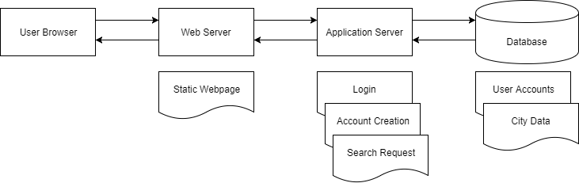

1. Component Diagram

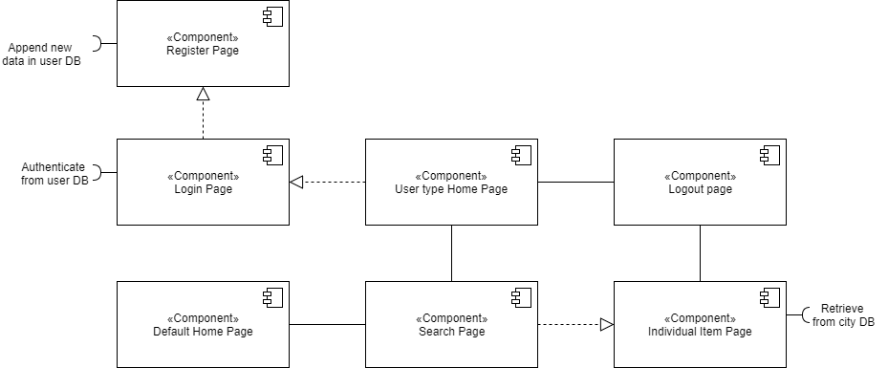

1. Data Flow Diagram

